Alexei Grigorovich Zakharov – Russian Spetsnaz Officer

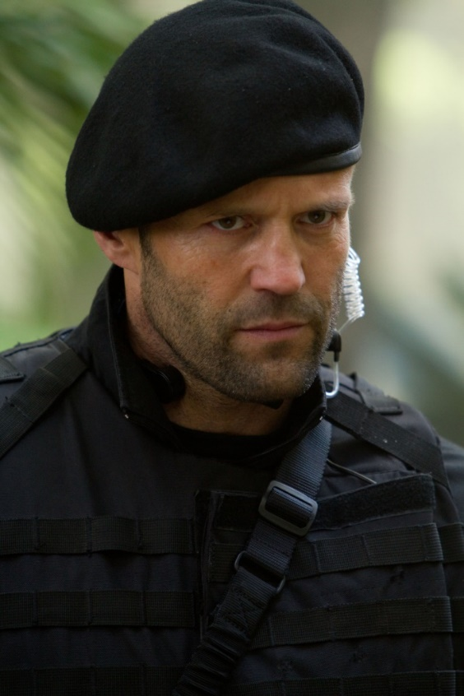 | Basic Information  Name: Capt. Alexei Grigorovich Zakharov | Age: 29  Race: Human (Tau’ri) | Class: Soldier  Origin, Background:  SENTRY  While often the task of soldiers, a trained and skilled sentry is a boon to many alien cultures. You’re trained to keep vigilant and never let your watch falter, a skill that comes in handy in a Phoenix team.  Bonus Proficiency: Perception  Long Night: You ignore the first night without rest, only suffering ill effects starting on the second night as if it were the first.  Origin, Racial:  TAU’RI MILITARY  As an operation of the USAF, the Phoenix Site is technically part of the human military. In recent years, General Loyer recruited from other branches of the military. The majority of personnel assigned to the Phoenix Site are from this background.  Required Race: Human (must be from Earth)  Basic Training: You are proficient in martial arts, longarms, or heavy armor (pick one). (Martial Arts)  Planet of Origin: Earth.
Proficiency Bonus: +2 | HP: 22 | DP: 3 | AC: 18 in Tac Vest | Speed: 6m | Init: 2 | Moxie: 1

STRENGTH | DEXTERITY | CONSTITUTION | INTELLIGENCE | WISDOM | CHARISMA
14  (+2) | 14  (+2) | 14  (+2) | 10  (+0) | 10  (+0) | 12  (+1)
STR Save +4 | DEX Save +2 | CON Save +4 | INT Save +0 | WIS Save +0 | CHA Save +0
Athletics +4 | Acrobatics +2  Sleight of Hand +2  Stealth +4  Pilot +2 |  | Engineering +0  Investigation +0  Nature +0  Science +0 | Animal Handling +0  Culture +0  Insight +0  Medicine +0  Perception +2  Survival +0 | Deception +1  Intimidation +1  Performance +1  Persuasion +1
Weapons and Armor
Name | Tech Level | Damage | Dam Type | Range | AC/Capacity | Reload | Special
Combat Knife | 2 | 1d6 | Slashing & Piercing | --- | --- | --- | Finesse
FN P90 | 2 | 2d6 | Piercing | 150m-300m | 30 | 1 Action | ---
Beretta M9 | 2 | 1d8 | Piercing | 50m-100m | 1 | 1 Action | Pistol
Tactical vest | 2 | N/A | N/A | N/A | 16+Dex (2) | N/A | Bulk 8+STR (11)
Martial Arts | --- | 1d6 | Bludgeoning | --- | --- | --- | ---

- Hit Points: You gain +10 HP.
- Ability Score Increase: Choose either Intelligence or Charisma to improve by +2. (Charisma)
- Proficiencies: Choose any two skill proficiencies. (Athletics and Stealth)
- Recovery: When you recover HP due to a short rest, you regain an additional +TD HP.
- Galactic Seeds: Humans are so common in the galaxy that they gain advantage on all Persuasion and Deception checks made during first contact with any group not having yet met visitors from another world.
Human Racial Features:
- Hit Points: 1 at first level, 6 per level for higher levels.
- Hit Die: d10.
- Determination Points: +1
- Armor Proficiencies: Light and Heavy Armor.
- Weapon Proficiencies: Common Weapons, Martial Arts, Sidearms, Longarms
- Saving Throws: STR and CON
- Equipment Kit: Base kit + longarm upgrade, camo kit, explosives (FN P90 with recoil compensation, +1 bulk)
- Tactical Flexibility: You’ve learned to direct your team in a variety of tactics. As an action you may activate a Tactic feat that you don’t know (see page 103). This tactic lasts for a number of rounds equal to your Charisma modifier (minimum 1). When the duration has run out, you may choose a tactic you know (if any) to re-activate automatically. Once you use this ability, you cannot use it again until you’ve taken a long rest.
- Tactics: You’ve trained extensively with a specific tactic, providing advantages to your team. Your team may benefit from one tactic at a time, and you may change your current tactic to another tactic you know with an action on your turn. Choose one tactic feat (see page 103) at 1st level and an additional tactic feat at 4th level. (Ambush)
Soldier Class Features:
- AMBUSH
MP Cost: 5
Requirement: Tactical Flexibility ability
You and your team members gain advantage on your first melee attack after any short or long rest.
- WEAPON SPECIALIZATION
MP Cost: 4
Requirement: None
Choose a type of weapon (such as Common, Sidearm, Longarm, etc.) You gain +1 to hit and
damage with the chosen weapon type. You may select this feat multiple times, selecting a different weapon type each time. You may select this feat a second time for the same weapon type at 8th level, a third time at 11th level, a fourth time at 14th level, and a fifth time at 17th level. (Longarm)
Feats:
Description
- Height: 5’ 10”
- Weight: 180 lbs.
- Hair: Bald (Brunette)
- Skin: White
- Eyes: Hazel
- Age: 29

Background
As part of the top-secret US-Russian Stargate Accord of 2000, select members of the Russian Federation military started joining off-world missions with their American counterparts as of 2002. While ostensibly under the command of Stargate Command, these Russian operatives also served the interests of their own government under the supervision of Col. Chekov, the Russian envoy and liaison to the SGC. All Russian SGC members are drawn from the ranks of the Russian Air Force.

One such Russian soldier was Capt. Alexei Grigorovich Zakharov. Born to a humble family of farmers outside of Moscow on July 4, 1976, young Alexei wanted much more in life than just being another failed experiment of the Communist agricultural collectivization scheme. He had two dreams – to win a medal in martial arts at the Olympics, and to become a cosmonaut. So, the short but scrappy young man studied kickboxing, wing chun and karate as he grew up, winning several awards and medals along the way. He also cracked open his textbooks and focused on getting an aeronautical engineering degree at the prestigious National University of Science and Technology (MISiS) in Moscow.

Despite years of dedicated effort, he never achieved either goal, so he joined the Russian Air Force, instead, in 1996. Eventually in 1997 he made his way into the elite 45th Independent Spetsnaz Regiment headquartered in Moscow. His physical and mental qualifications were more than acceptable. Of course, it didn’t hurt that Alexei was the nephew of up-and-coming bureaucrat Gen. Ivan Vasilyevich Zakharov.

Ivan Vasilyevich, or “Uncle Vanya” as he is known to his only nephew, eventually became the Deputy Minister of Defense of Moscow. The senior Zakharov had no children of his own, so he was pinning all his nepotistic hopes on Alexei. While proud of the boy’s accomplishments, he was also disappointed at his failures. Yet when the opportunity presented itself to recommend Alexei as a potential member of an SGC team, Ivan Vasilyevich did just that. And the captain was accepted into the program.

Alexei did well in his SGC training and was initially placed into the Russian unit (SG-20) in Cheyenne Mountain in Colorado in early 2002. His record there brought him to the attention of Maj. General P.K. Loyer, so Alexei was transferred off-world to the Phoenix site later that year to be part of Loyer’s operation.

Equipment
• Tactical Vest
• 3 Uniforms
• Tactical Radio
• Flashlight
• Water Purifier
• Filtration Mask
• Multi-tool
• Personal First Aid Kit
• Climate Clothing
• Combat Tent

